NATIONAL JUNIOR COLLEGE
PRELIMINARY EXAMINATIONS
Higher 2
CANDIDATE
NAME
SUBJECT  CLASS |  | REGISTRATION NUMBER
CHEMISTRY  Paper 1 Multiple Choice  Additional Materials: Multiple Choice Answer Sheet  Data Booklet |  |  |  | 9746/01  Fri 17 September 2010  1 hour

READ THESE INSTRUCTIONS FIRST
Write in soft pencil.
Do not use staples, paper clips, highlighters, glue or correction fluid.
Write your name, subject class and registration number on the Answer Sheet in the spaces provided.
There are forty questions on this paper. Answer all questions. For each question there are four possible answers A, B, C and D.
Choose the one you consider correct and record your choice in soft pencil on the separate Answer Sheet.
Read the instructions on the Answer Sheet very carefully.
Each correct answer will score one mark. A mark will not be deducted for a wrong answer.
Any rough working should be done in this booklet.
This paper consists of 20 printed pages and 0 blank page.
Section A
For each question, there are four possible answers labelled A, B, C and D. Choose the one you consider to be correct.
1 | 1.2 g of an oxide MO of a metal M was dissolved in an excess sulfuric acid. 25.0 cm³ of 0.10 mol dm⁻³ potassium dichromate(VI) solution was required to oxidise M²⁺ to M³⁺.  What is the relative atomic mass of M?
 | A | 52
 | B | 56
 | C | 64
 | D | 80
2 | In 1898 Marie Curie found that uranium minerals were highly radioactive and underwent decay to other elements. The following equation is an example of such decay.  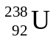 element A + 8 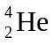 + 6 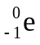  Which of the following gives the identity of element A?  Mass number atomic number
 | A | 206 82
 | B | 206 86
 | C | - 76
 | D | 234 90
3 | Which of the following statements about the orbitals is true?
 | A | Electrons in a sp² orbital are held more closely towards the nucleus than electrons in a sp³ orbital.
 | B | The length of the C-C bond formed by sp²-sp² overlap is longer than that formed by sp³-sp³ overlap.
 | C | The shape and size of s-orbitals remain the same as the principal quantum number increases.
 | D | The energy level of the orbitals of the same principal quantum shell is of the order: s > p > sp³.

4 | - In Which of the following compounds does the underlined element contain unpaired electrons?
 | A |  | PH₃
 | B |  | Cu₂I₂
 | C |  | SO₂
 | D |  | MnO₂
5 | The Van der Waal’s equation for a non-ideal gas is  (P + 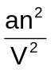 )(V - nb) = nRT  The term b is a correction for
 | A |  | the space occupied by real molecules.
 | B |  | collisions between real molecules not perfectly elastic.
 | C |  | the existence of attractive forces between real molecules.
 | D |  | the existence of repulsive forces between real molecules.
6 | Which of the following does not apply to element Q?  No. of electrons removed  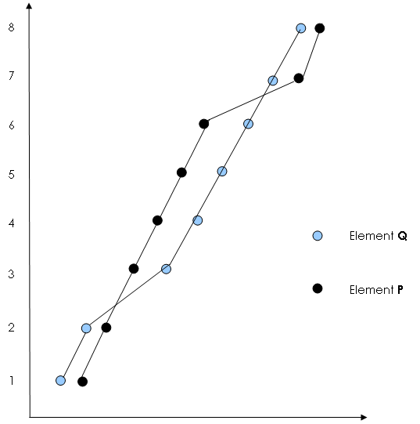  log₁₀ (ionization energy)
 | A |  | Q is more metallic than P.
 | B |  | Q can form an ion of oxidation number 2.
 | C |  | Less energy is required to remove the 8th electron from Q than from P.
 | D |  | The graph shows the log₁₀(ionization energy) for all n=1 and n=2 electrons.
7 | A mixture of 10 cm³ of methane and 10 cm³ of ethane was sparked with an excess of oxygen. After cooling to room temperature, the residual gas was passed through aqueous potassium hydroxide of concentration 0.100 mol dm⁻³. What is the volume in cm³ of aqueous potassium hydroxide required to react with the residual gas?
 | A | 12.5
 | B | 13.4
 | C | 25.0
 | D | 26.8

8 | Which of the following has the smallest bond angle?
 | A |  | H₂S
 | B |  | SCl₂
 | C |  | BCl₄⁻
 | D |  | NO₃⁻
9 | The standard enthalpy changes of formation of H₂O(l) and CO₂(g) are -285.8 kJ mol⁻¹ and -393.5 kJ mol⁻¹ respectively. If the standard enthalpy change of combustion of methanol is -715 kJ mol⁻¹, what is the standard enthalpy change of formation of methanol in kJ mol⁻¹?
 | A | +35.7
 | B | -250.1
 | C | -357.8
 | D | -893.1
10 | The Haber synthesis of ammonia requires a 3:1 mixture of hydrogen and nitrogen. This mixture is produced from methane where some methane reacts with steam and some with air.  The overall changes are: CH₄ + 2H₂O → CO₂ + 4H₂  CH₄ + O₂ + 4N₂ → CO₂ + 2H₂ + 4N₂  Which of the following gives the fraction of the total amount of methane which reacts with steam to obtain a 3:1 mixture of hydrogen and nitrogen?
 | A
 | B
 | C
 | D
11 | Two first order reactions were started at the same time. Reaction A had an initial concentration of 1 mol dm⁻³ and a half-life of 20 minutes. Reaction B had an initial concentration of 4 mol dm⁻³ and a half-life of 10 minutes. At what time would the concentrations in the two reactions become equal?
 | A | 15 min
 | B | 35 min
 | C | 40 min
 | D | 50 min
12 | Use of the Data booklet may be relevant to this question.  Three electrochemical cells are set up as shown below. The e.m.f in volts is shown on each voltmeter.  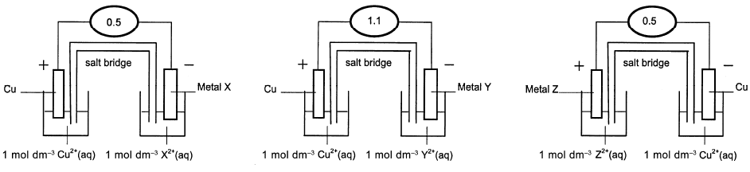  The e.m.f indicates the order of reactivity of the metals. The order of the weakest to the strongest reducing agent is
 | A | X, Cu, Y, Z
 | B | Cu, Z, X, Y
 | C | Z, Cu, X , Y
 | D | Y, X, Z, Cu

13 | The same quantity of electricity that caused the deposition of 5.0 g of silver from a silver nitrate solution liberated 3.02 g of an element B from a solution containing B^{n+} ions. If the relative atomic mass of B is 197, the value of n is
 | A |  | 1
 | B |  | 2
 | C |  | 3
 | D |  | 4
14 | Consider the following series of molecules or ions:  The formulae of the hypothetical entities x, y and z are:
  SbF₅ | TeF₆ | IF₇ | x
  SbF₃ | TeF₄ | IF₅ | XeF₆
  y | z | IF₄⁻ | XeF₄
  SbF₅ | TeF₄ | IF₃ | XeF₂
 | A |  | XeF₆²⁻ SbF₅ TeF₂
 | B |  | XeF₈ SbF₄³⁻ TeF₄²⁻
 | C |  | XeF₈ SbF₃ TeF₄
 | D |  | XeF₈ SbF₅ TeF₄²⁻
15 |  | A metallic element X has only one oxidation state in all of its salts, most of which are white. The sulfate of element X is not soluble in water. Which is the electronic configuration of an atom of element X?
 |  | A | 1s² 2s² 2p³
 |  | B | 1s² 2s² 2p⁶ 3s²
 |  | C | 1s² 2s² 2p⁶ 3s² 3p⁶ 3d² 4s²
 |  | D | 1s² 2s² 2p⁶ 3s² 3p⁶ 3d¹⁰ 4s² 4p⁶ 5s²

16 | Which of the following statements is correct?
 | A | The first ionisation energies of the elements in Period 3 show a general decrease from sodium to chlorine.
 | B | The strength of the intermolecular forces increases from hydrogen fluoride to hydrogen bromide.
 | C | The ability of a halide ion to act as a reducing agent decreases from fluoride to iodide.
 | D | The electronegativities of Group II elements decrease from magnesium to barium.
17 | Nickel(III) chloride forms a compound with ammonia in which the coordination number is 6. One mole of the compound reacts with 2 moles of silver nitrate to form a white precipitate.  Which of the following correctly shows the formula of this compound?
 | A | Ni(NH₃)₃Cl₃
 | B | Ni(NH₃)₄Cl₃
 | C | Ni(NH₃)₅Cl₃
 | D | Ni(NH₃)₆Cl₃

18 | In an experiment, a 0.1 mol dm⁻³ solution of hydrochloric acid was added to 10 cm³ of a solution that was 0.1 mol dm⁻³ with respect to chromium(III) ions. As the volume of hydrochloric acid was varied, the absorption of light of a particular wavelength was monitored. The following graph was obtained.  absorption  0  10  5  20  25  15  Vol of 0.1 mol dm⁻³ HCl / cm³  The complex formed at the maximum absorption could be:
 | A | CrCl₃
 | B | [CrCl₆]³⁻
 | C | CrCl₃(H₂O)₃
 | D | [CrCl₂(H₂O)₄]⁺

19 | White precipitate & coloured solution  White precipitate & brown solution  White precipitate  Pb(NO₃)₂(aq)  KI(aq)  H₂O₂(aq)  Pungent gas  Na₂S₂O₃(aq)  Y(aq)  The compound Y in the above reaction scheme is
 | A | FeCl₃
 | B | CuCl₂
 | C | CuSO₄
 | D | Fe₂(SO₄)₃

20 | Which of the following statements about the molecule shown below is correct?
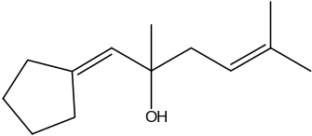

 | A | It can exist as geometric isomers.
 | B | It reacts with 3 moles of hydrogen bromide.
 | C | It undergoes nucleophilic addition reactions.
 | D | It reacts with acidified potassium dichromate(VI).
21 | 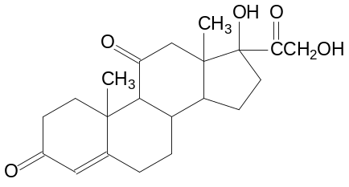The structure of cortisone is shown below.

 | When it is completely reacted with lithium aluminum hydride with ether at room temperature, how many chiral centres does the product molecule possess?
 | A | 7
 | B | 8
 | C | 9
 | D | 10
22 | The following are the likely products when 2-bromo-2-methylbutane reacts with ethanolic potassium hydroxide except
 | A |  | 2-methylbut-1-ene
 | B |  | 1-methylbutan-2-ol
 | C |  | 2-methylbutan-2-ol
 | D |  | 2-methylbut-2-ene
23 | The Williamson’s ether synthesis involves a nucleophilic substitution of an organic halogen compound. Which of the following reagents can be used for the synthesis of methoxyethane, CH₃CH₂OCH₃ starting from bromoethane?
 | A | sodium hydroxide in methanol
 | B | sodium with methanol
 | C | potassium ethoxide
 | D | methanol

24 | The reaction of ethanol with sulfuric acid is shown in the scheme below:  CH₂=CH₂  Excess acid, 170 ºC  I  II  III  CH₃CH₂OH  CH₃CH₂OSO₂OH  Conc. H₂SO₄  Excess water  Excess alcohol, 140 ºC  CH₃CH₂OCH₂CH₃  \Which of the following is not true of the above scheme?
 | A | Concentrated phosphoric acid can be used in place of concentrated sulfuric acid in reaction I.
 | B | This reaction always yields a mixture of the two products.
 | C | Reactions I and III involve the same mechanism.
 | D | Reaction II shows the elimination of water.

25 | Which of the following cannot be used to distinguish between the following compounds?  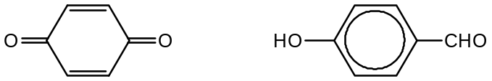
 | A | Hot acidified K₂Cr₂O₇
 | B | Neutral iron(III) chloride
 | C | Silver diammine complex
 | D | 2,4-dinitrophenylhydrazine
26 | A student treated benzene in a 3-step reaction to yield N–phenyethanamide,  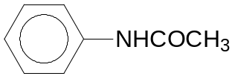  Which of the following gives the correct sequence?  Step 1 Step 2 Step 3
 | A | Ethanolic potassium cyanide Sn, conc HCl Propanone
 | B | Conc H₂SO₄ and conc HNO₃ LiAlH₄ in dry ether Ethanoyl chloride
 | C | Conc H₂SO₄ and conc HNO₃ Zn, conc HCl Ethanoyl chloride
 | D | Chlorine in presence of FeCl₃ Ethanolic ammonia Ethanoyl chloride

27 | Which of the following shows the correct order of increasing base strength?
   | Weakest base |  |  | Strongest base
  A | 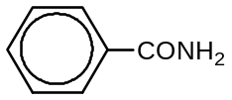 | 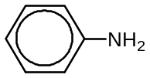 | 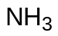 | 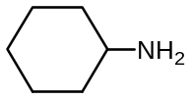
  B
  C
  D
28 | 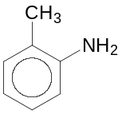Which of the following is the least likely reaction of compound X?  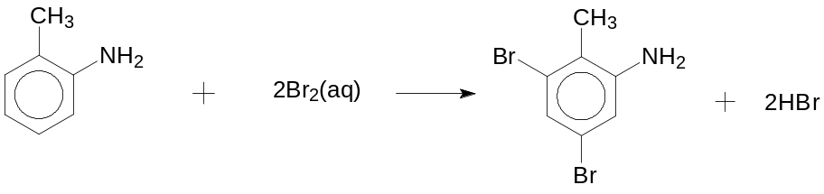  Compound X  A  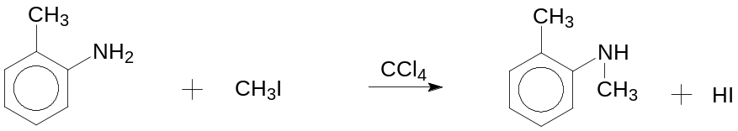  B  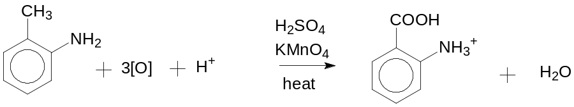  C  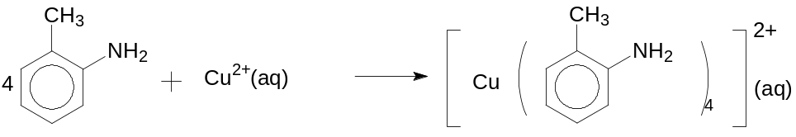  D
29 | Anhydrides are acid derivatives which can be considered to be formed from the dehydration of acids. The chemistry of the acid anhydrides is very similar to that of the acid chlorides, except that they are a little less reactive. The formation of benzoic anhydride is shown below:  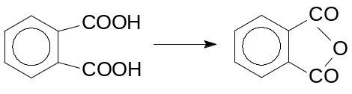  Which of the following is not true for benzoic anhydride?
 | A | It reacts with ethanol.
 | B | It has little solubility in water.
 | C | It reacts with aqueous sodium hydroxide to give the sodium salt.
 | D | It gives an orange solid when reacted with 2,4-dinitrophenylhydrazine.
30 | A carbonyl compound can be converted into an alkene by means of the Wittig reaction where a phosphorus ylide is involved as follows:
(C₆H₅)₃P=CH₂
an ylide
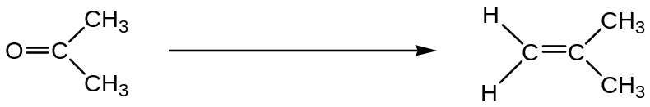

Which of the following pairs of compounds might you use to prepare the following alkene?
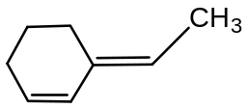
 | A | (C₆H₅)₃P=CHCH₃ | 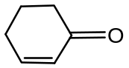
 | B | (C₆H₅)₃P=CH₂ | 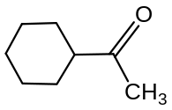
 | C | (C₆H₅)₃P= CHCH₃ | 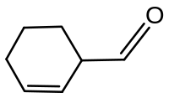
 | D | (C₆H₅)₃P=CH₂ | 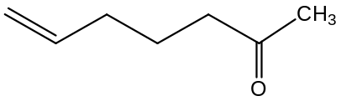

Section B

For each of the questions in this section, one or more of the three numbered statements 1 to 3 may be correct.

Decide whether each of the statements is or is not correct (you may find it helpful to put a tick against the statements that you consider to be correct).

The responses A to D should be selected on the basis of
A | B | C | D
1, 2 and 3  are  correct | 1 and 2  only are  correct | 2 and 3  only are  correct | 1 only  is  correct

No other combination of statements is used as a correct response.

31 | Which of the following is an example of a disproportionation reaction?
 | 1 | 2NaO₂ + 2HCl → 2NaCl + H₂O₂ + O₂
 | 2 | Cl₂ + 6NaOH → 5NaCl + NaClO₃ + 3H₂O
 | 3
32 | For the reaction represented by the equation shown below,  2H₂(g) + 2NO(g) 2H₂O(g) + N₂(g)  The rate equation: Rate = k[H₂][NO]²  Assuming that each 10 K rise in temperature doubles the rate, which of the following will  increase the rate by a factor of four?
 | 1 | no temperature change but with 4 × [H₂], keeping [NO] constant.
 | 2 | a 10 K temperature increase with 2 × [H₂], keeping [NO] constant.
 | 3 | a 10 K temperature increase with 2 × [NO], keeping [H₂] constant.

The responses A to D should be selected on the basis of
A | B | C | D
1, 2 and 3  are  correct | 1 and 2  only are  correct | 2 and 3  only are  correct | 1 only  is  correct

No other combination of statements is used as a correct response.

33 |  | For the dimer-monomer system,  A₂(g) 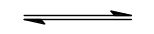2A(g)  the equilibrium constants, K_{p}, are 4 x 10⁴ Pa at 15 ºC  and 8 x 10⁴ Pa at 25 ºC  Which of the following statements are true?
 |  | 1 | The formation of A₂ from A is exothermic.
 |  | 2 | Doubling the total pressure of the system reduces the percentage dissociation to half the original.
 |  | 3 | Addition of argon at constant volume shifts the equilibrium position to the right.
34 |  | The standard electrode potentials, E^{θ}, of three metals in water and in liquid ammonia are given below:  Which of the following conclusions can be drawn from these data?
  Electrode | E^{θ} (H₂O) /V | E^{θ} (NH₃) /V
  K⁺/K  Ca²⁺/Ca  Na⁺/Na | -2.93  -2.87  -2.71 | -1.98  -1.74  -1.85
 |  | 1 | Potassium is a stronger reducing agent in liquid ammonia than in water.
 |  | 2 | Calcium is a weaker reducing agent than sodium in liquid ammonia.
 |  | 3 | Calcium is a stronger reducing agent than sodium in water.

The responses A to D should be selected on the basis of
A | B | C | D
1, 2 and 3  are  correct | 1 and 2  only are  correct | 2 and 3  only are  correct | 1 only  is  correct

No other combination of statements is used as a correct response.

35 |  | The data below refer to 6 elements, lettered T to Y (these letters are NOT chemical symbols).  Which of the following statements are true?
  Element | T | U | V | W | X | Y
  Atomic Number | Z | Z+1 | Z+2 | Z+3 | Z+4 | Z+5
  Boiling point/ K | 73 | 93 | 83 | 23 | 1163 | 1373
 |  | 1 | The first ionization energy of T is higher than that of U.
 |  | 2 | The ionic radius of V is smaller than the ionic radius of X.
 |  | 3 | The hydride of V has a higher boiling point than the hydride of Y.
36 |  | Which of the following explain why hydrogen iodide cannot be prepared by adding concentrated sulfuric acid to solid potassium iodide?
 |  | 1 | Iodide ions are oxidised to iodine.
 |  | 2 | Hydrogen iodide is not displaced by sulfuric acid.
 |  | 3 | The products are contaminated by sulfur compounds.

The responses A to D should be selected on the basis of
A | B | C | D
1, 2 and 3  are  correct | 1 and 2  only are  correct | 2 and 3  only are  correct | 1 only  is  correct

No other combination of statements is used as a correct response.

37 |  | The French chemist, Eugene Peligot, discovered that Group II salts of carboxylic acids on heating decompose to give a metal carbonate and a carbonyl compound. An example of such decomposition is as shown:  (RCOO)₂Ca → CaCO₃ + R₂CO  The likely products(s) obtained when a mixture of calcium ethanoate and calcium methanoate is heated are:
 |  | 1 | CH₃COCH₃
 |  | 2 | CH₃CHO
 |  | 3 | HCHO
38 | Which mixtures, on heating, produce an alkaline gas containing deuterium, D?
 | 1 |  | CH₃CH₂CONHCH₃ and NaOD in D₂O
 | 2 |  | (ND₂H₂)₂SO₄ and NaOD in D₂O
 | 3 |  | C₆H₅CH₂CN and DCl in D₂O

The responses A to D should be selected on the basis of
A | B | C | D
1, 2 and 3  are  correct | 1 and 2  only are  correct | 2 and 3  only are  correct | 1 only  is  correct

No other combination of statements is used as a correct response.

39 | The rod cells in the retina at the back of the eye contain an alcohol called retinol which is responsible for their sensitivity to light. Retinol is oxidised by an enzyme-catalysed reaction to retinal with the following structure:  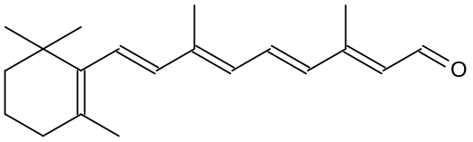  retinal  Which of the following statements about retinal are correct?
 | 1 | The molecular formula of retinal is C₂₀H₂₈O.
 | 2 | It can react with NH₂OH.
 | 3 | The structure of its cis isomer is | 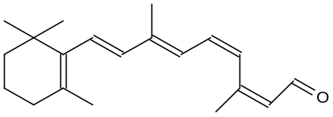

40 | Compound A was used in the following synthetic route.  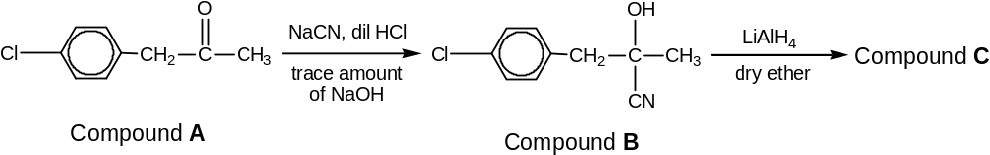  Which statement is true regarding the synthetic route?
 | 1 | There are 3 sp³, 6 sp² and 1 sp hybridized carbon atoms in Compound B.
 | 2 | The synthetic route involves addition and reduction reactions.
 | 3 | Compound B is optically active.

